Exercise

01)



02)

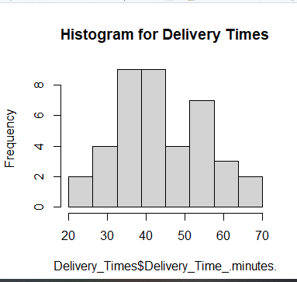

03)

Mostly symmetric but slightly skewed to the right.

04)

